# Braining storm

1. Hamburger Menu

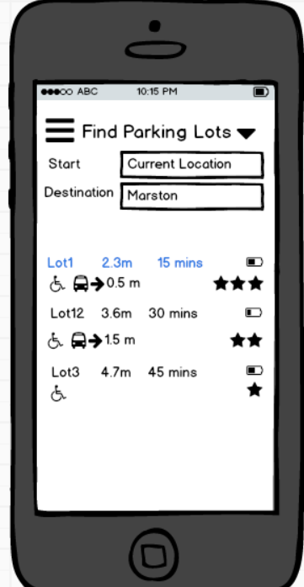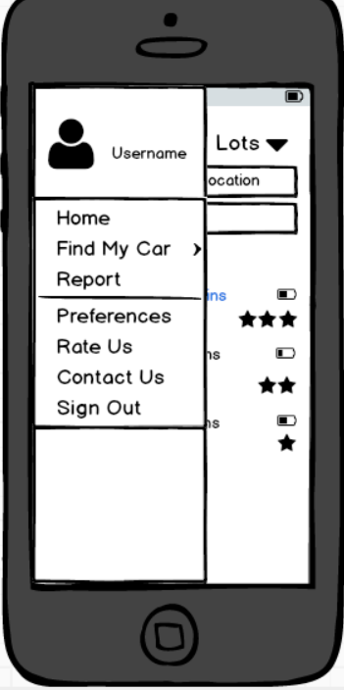

Opportunities: Save a lot of space, Menu items is clear and easy to find.

Breakdowns: No space for back button, which is very important in navigation.

1. Column Layout

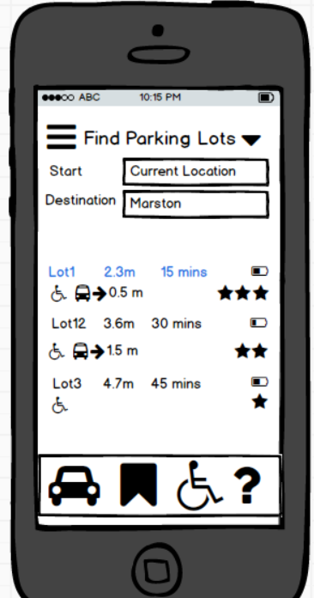

Opportunities: easy to find and clear navigation, User can easily find functions.

Breakdowns: columns waste a lot of space and may result important items such as map too small.

1. Grid Layout

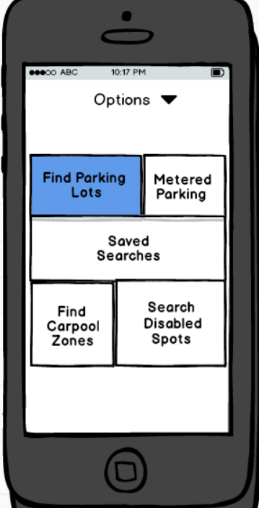

Opportunities: Clear navigation to help users do what they want step by step especially there’re a lot of functions.

Breakdowns: Most of functions may seldom or never used by users, users have to waste their time to have a look at it.

1. Table head in list of parking lot

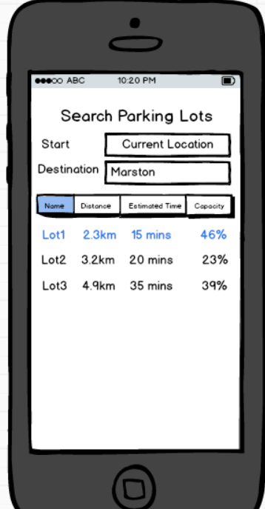

Opportunity: Clear layout to show users what data it is in every column.

Breakdowns: Space is too small for every column especially there’re a lot of items. There’s no variety in font size, color and no image make users tired to look at.

1. Tab-bar application

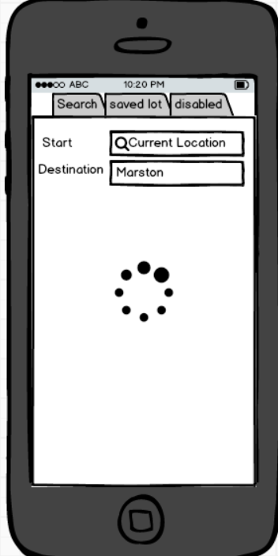

Opportunity: Easy to switch functions especially when there’re a few functions that can be used very often.

Breakdowns: Is not proper when there’s a main function and some supportive functions. Users may accidentally touch the bar.